**ACKNOWLEDGEMENT**

We would like to express a deep sense of gratitude to my guide **Dr. V. Manjula**  Associate professor, Department of Civil Engineering**, DR M.G.R EDUCATIONAL AND RESEARCH INSTITUTE** For his valuable suggestions in the analysis of the problems, overall supervision and guidance for the completion of this project work.

We are highly grateful to **DR T KAVITHA**, Head of the Department of Civil Engineering for providing the required facilities in the department for successful completion of this project.

We are very much thankful to the President **ACS ARUN KUMAR** of **DR MGR EDUCATION AND RESEARCH INSTITUTE**. For their encouragement and cooperation to carry out this work.

We are very much thankful to our classmates for their support in completion of our project.

We express sincere thanks to all the teaching staff of **Department of Civil Engineering** for providing a great assistance in the accomplishment of our project.

We also express my thanks to all the non-teaching staff of **Department of Civil Engineering** for giving all the support and suggestions to complete our project.

We are very much thankful to the management of **DR MGR EDUCATIONAL AND RESEARCH INSTITUTE**  for their encouragement and cooperation to carry out this work.

**CONTENTS**

**S.NO TITLE PAGE.NO**

1 INTRODUCTION **09**

* 1. General **09**

**1.**2 Objective & Scope **10**

* 1. Selection of plot and study **11**

**1.4** Methodology **12**

1. LITERATURE REVIEW 13

3 PLANNING 20

3.1 Regulation of National building code of India 20

3.2 Plinth regulation 20

3.3 Rest room 20

3.4 Parapet wall 20

3.5 Boundary wall 21

3.6 Sceptic tank 21

3.7 Stair case 21

4 SIZE OF BEAM & COLUMN 26

5 LOAD CALCULATION 28

CONCLUTION 30

REFRANCE 31

**LIST OF FIGURES**

1. SITE PLAN (Figure-1) 08

2. BASEMENT(Figure-2) 19

3. GROUND FLOOR PLAN (Figure-2) 19

4. G+1 FLOOR PLAN (Figure-3) 20

5. G+2 FLOOR PLAN (Figure-4) 20

6. ELEVATIONS (Figure-5) 21

7. COLUMN LAYOUT(Figure-6) 22

**LIST OF SYMBOLS**

**A** – Area

**Ag** – ```Area of Gross section

**As** – Area of flexural steel

**Asc** – Area of compression steel

**Ast** – Area of tension Steel

**Asv** – Area of vertical stirrup

**Av** – Area of vertical stirrup

**b** – Width of a section

**bf** – Width of flange

**bw** – Width of web

**c** – Distance of neutral axis from compression surface

**d** – Effective depth of a section

**D** – Overall depth of a section

**fck** –Compressive strength of concrete – IS 456:2000

**fs** – Stress in tension steel

**fy** – Tensile strength of steel – IS 456:2000

**k** – Effective length factor for columns

**L** – Length of a section

**l** – Length of column

**leff** – Effective length of a section

**lu** – Unsupported length of column

**Mu** – Factored moment

**Mux** – Moment about xx-axis

**Muy** – Moment about yy-axis

**Pt** – Percentage of steel

**P** – Unfactored concentrated load

**Po** – Axial strength of a concentrically loaded column

**Pu** – Factored axial load r – Radius of

**St** – Tie spacing

**Sv** – Spacing for vertical stirrups

**Vus** – Shear to be resisted by stirrup

**Xu** – Neutral axis depth

**α** – ratio of stiffness

**β** – Reinforcement ratio

**e**– Strain

**et** – Tensile strain

**ζ** – Shear stress of concrete

**λ** – Slenderness ratio

**ABSTRACT**

In this project planning, analysis and structural design has been done for a commercial building of shopping mall based on all Indian standard codes of practice. Detailing drawings pertaining to the structural design of shopping mall are presented using Auto CADD. Analysis of the structure is done using manually. All the structural members like slabs, beams, columns and footings are designed using Indian standard code is 456-2000, is-875 and design aid sp-16. The structural components are designed by limit state method. Materials are used as specified by National Building Code. Concrete M30 grade concrete and fe415 steel bars are considered for all the design. Brick walls are worked in C:M 1:5 mix 230 mm thick. The mall is built with almost all the amenities required for the people to get entertained in their busy schedule. This structure is going to be designed with the view that all the entertainment facilities should be made available under one roof. The overall plot area of the mall is 45000 sq ft and the area is around 48,600 sq. ft.

**CHAPTER-1**

**INTRODUCTION**

**1.1GENERAL**

This project deals with the planning, analysis and designing of a Shopping mall. A Shopping Mall is a building designed for entertaining the people. As our country is the fastest growing country across the globe so the need of shelter for highly populated cities where the cost of land is high and further horizontal expansion is not possible due to unavailability of space, so the only solution is vertical expansion.

Structural design is the primary aspect of civil engineering. The foremost basics in structure is the design of simple basic components and members of a building like slabs, beams, columns, and footings. To design them it is important to first obtain the plan of the building. Thereby depending on the suitability plan layout of beams and the position of columns are fixed. Thereafter, the vertical loads are calculated namely the dead load and live load. Once the loads are obtained, the component takes the load first ie. The slabs can be designed.

Designing of slabs depends upon whether it is a one-way or a two-way slab, the end condition and the loading. From the slabs, the loads are transferred to the beam. The loads coming from the slabs onto the beam may be trapezoidal or triangular. Depending on this, the beam may be designed. Thereafter, the loads (mainly shear) from the beams are taken by the columns. For designing columns, it is necessary to know the moments they are subjected to for this purpose. After this the designing of column is taken up depending on end conditions, moments, eccentricity and if it is a short or slender column. Finally, the footings are designed based on the loading from the column and the soil bearing capacity value for that particular area. Most importantly, the sections must be checked for all the components with regard to strength and serviceability**.**

AutoCAD is a computer-aided drafting software program used to create blueprints for buildings, bridges and computer chips, among other things. AutoCAD is a 2-D and 3-D computer-aided rafting software application used in architecture, construction and manufacturing to assist in the preparation of blueprints and other engineering plans. Professionals who use AutoCAD are often referred to as drafters.

**OBJECTIVES**

* Planning of shopping building with proper ventilation and sunlight.
* Analysis of frame by STAAD Pro.
* Designing of all structural members based on limit state method of design.
* Designing of other miscellaneous structures like septic tank by working stress method.
* To suggest a cost-effective building.

**1.2 SCOPE**

• Design of slab by using limit state method.

• Preliminary design of beam and slab is done to adopt the beam and column size for the respective designs.

• Analysis of frame is done using STAAD Pro V8i

• Design of beam is done as per IS code.

• Design of column is done according to SP-16.

• Design of footing is done by using limit state method.

• Design of dog-legged and open wall staircase.

• Design of septic tank as per NBC requirements.   
**1.3 SELECTION OF PLOT AND STUDY**

Selection of plot is very important for building a shopping mall. Site should be in good place where there is community and service is convenient but not so closed that becomes a source of inconvenience or noisy. The conventional transportation is important not only because of present needs but for the retention of property value in future closely related to are transportation, shopping, facilities also necessary. One should observe the road condition whether there is indication of future development or not in case of undeveloped area.

The factor to be considered while selecting the building site are as follows:-

• Access to park & playground.

• Agriculture polytonality of the land.

• Availability of public utility services, especially water, electricity & sewage disposal.

• Contour of land in relation to the building cost and cost of land.

• Distance from places of work. • Ease of drainage.

• Location with respect to Shopping Mall, college & public buildings.

• Nature of use of adjacent area.

• Transport facilities.

• Wind velocity and direction. 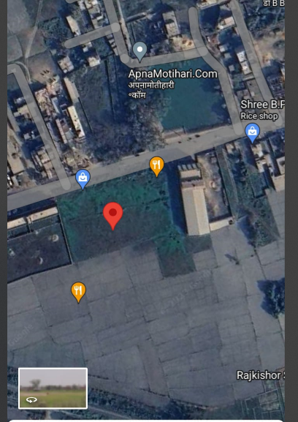

**Site location**

**Figure-1**

METHODOLOGY

Proposed drawings

Gravity load

Calculation

Literature

review

Planning

Selection of Plot

Load combination

Gravity load

Calculation

Proposed

drawings

Fixing of column and beam size and design

Limit state method

Analysis of RCC

elements

Detailing drawings

Check serviceability

**LITERATURE REVIEW**

|  |  |  |  |
| --- | --- | --- | --- |
| **Author** | **Title** | **Abstract** | **Conclusion** |
| **1. Ankit Gupta, Archita Jain &Varun Luhadiya**  **PUBLISHED IN 2016** | Structural planning and design of three stored framed building | Analysis the load of slab, beam, column and footings. In order of design.  1st obtain the plan of the building.  Design of slab is depend upon ones way or two way. | * The design of R.C.C structured building done by Limit State Theory. * Moment distribution method is adopted for calculating the moment over the spans. * It is evident that load in a residential building is so less that slab were safe in all aspects with the minimum reinforcement as per IS 456- 2000. * Beams are designed individually as continuous beams & reinforcement is provided for as well as for negative moment. |

|  |  |  |  |
| --- | --- | --- | --- |
| 1. **FAISAL MEHARAJ WANI AND TEAM**  * **PUBLISED IN 2019.** | Design and analysis of residential building. | * Design and analysis was done as limit state method. * 1st obtain the plan of the building. Plan draw with auto cad software. * ANALYSIS and Design was done manually * Analysis the force and moment will be accomplished with E-Tab. * And compare both. | * Analysis is done by using ETABS software and successfully verified manually as per IS456. * Calculation by both manual work as well as software analysis gives almost same result. Shear force & bending moment increases for both beams & columns as the storey height increases. |

|  |  |  |  |
| --- | --- | --- | --- |
| 1. **Lajan B. Abdalla** 2. **Project is published at**   **Ernakulam, Kerala by Nasreen N khan.**  **PUBLISHED IN 2018** | * Analysis & Design of a Residential Building   Analysis & design of apartment building. | * The aim of this project is to analysis & design the multistory resistance building manually. * The building was consist of ground floor, first floor second floor. * The modelling is drafted to AUTOCAD. Designing was done manually of slab, beam, column, footing, and stair case. * And design is cross check to STAAD PRO software. | * The effect of earthquake load on the all member is significant. * The effect of wind load was not much significant compared with the earthquake load. * The lateral load analysis it is very important in design of building & other structures. * Due to the effect of earthquake load the internal column their behaviour are changed from axially column to bai axially column. * Design of torsion beams in necessary & important. But for the interior beams if there is no a significant difference load& span we can neglect it. * Analysis & Design is done by manually & cross check with STAAD PRO Software * Structural element like ramp, shear wall and retaining walls are provided. * Design of apartment building as IS 456 -2000 code |

|  |  |  |  |
| --- | --- | --- | --- |
| 1. **Aman dawadi Team’s**   **PUBLISHED IN 2021** | * Structural analysis and design of commercial complex | * Analysis works are done using SAP2000 v16 as analytical tool. * MS-Excel is used for general calculations. * Ductile Detailing is drafted using AutoCAD2007. * Building is Analyzing with under of seismic load because Kathmandu is hot zone of earthquake. | * For tension reinforcement curtailment was made of specific distance from edge of the support as IS 13920. * For compression reinforcement curtailment was made at mid part of beam. * Spacing of strips are also design as per ductility code IS 13920:1993. * The maximum axial load & moments acting along the length of the column was considered for the design of the column section by Limit state method. |

|  |  |  |  |
| --- | --- | --- | --- |
| 1. **Deshpande, Manoj. N. Pai, Pawan & Ashish pednekar**   **PUBLISHED IN 2017**   1. **M. Mallikarjun & Dr P V Surya Prakash**   **PUBLISHED IN 2019**   1. **Mohd Zohair**  * **PUBLISHED IN 2018**  1. **Aman dawadi Team’s**   **PUBLISHED IN 2020**   1. **Project is published at Ernakulam, Kerala by Nasreen N khan.**   **PUBLISHED IN 2021** | **• A**nalysis, design and estimation of basement G + 2 residential building  Analysis & Design of a multi storied residential building  Analysis and design of multistorey building  Structural analysis and design of commercial complex  Analysis & design of apartment building. | * Building was analysis and design with E-tabs software version 15. * Dead loads are calculated based on material propertied and dimension. * Live load are consider based on is 875 –part 2. * Footing were designed based base of safe bearing capacity.   The main purpose of the project is to ensure & enhance the safety keeping careful balance between economy & safety.   * A multistorey is a building that has multiple floors above the ground. It can be a residential or commercial building. * In this project the analysis and design of multistorey building G+4.   Analysis works are done using SAP2000 v16 as analytical tool.  • MS-Excel is used for general calculations.  • Ductile Detailing is drafted using AutoCAD2007.  • Building is Analyzing with under of seismic load because Kathmandu is hot zone of earthquake.  The modelling is drafted to AUTOCAD.  • Designing was done manually of slab, beam, column, footing, and stair case.  • And design is cross check to STAAD PRO software. | * Checked the deflection and shear of slab and beam are safe. * Column are designed using sp-16 and checked for intraction formula and found to be safe. * Footing were designed and checked for one way or two way shear was found. • Using software helps to get faster results & simultaneously designing can also be done for that members * Load combination can be altered easily. • ETABS gives more economical & convenient results than manual design results. * If the height of the structure is increased the stiffness phenomenon (slenderness effect )i.e. long column effect will come in to the picture . As a result the amount of deflections are far greater than the codal provisions (IS – 456). * Economizing the column by means of column orientation is longer span longer direction will reduce the amount of bending as a result the area of steel is also reduced. * In this report a design of multistorey building G+4 is presented * The durability of a building depends mainly on proper construction and proper use of construction materials.   For tension reinforcement curtailment was made of specific distance from edge of the support as IS 13920.   * For compression reinforcement curtailment was made at mid part of beam.   • Spacing of strips are also design as per ductility code IS 13920:1993.  • The maximum axial load & moments acting along the length ofthe column was considered for the design of the column section by Limit state method.   * Analysis & Design is done by manually & cross check with STAAD PRO Software * Structural element like ramp, shear wall and retaining walls are provided. * Design of apartment building as IS 456 -2000 code. |

**CHAPTER-3**

**PLANNING**

**3.1 REGULATIONS OF NATIONAL BUILDING CODE OF INDIA**

The National Building code of India is a single document in which, like a network, the information contained in various Indian Standards is woven into a pattern of continuity and cogency with the interdependent requirements of sections carefully analyzed and fitted into make the whole document a cogent continuous volume.

A continuous thread of ‘preplanning’ is woven which, in itself, contributes considerably to the economies in construction particularly in building and plumbing services.

**3.2 Plinth Regulations**

No plinth or any part of the building should be less than 30cm above the determined level of:

• The center part of abutting street.

• The foot path of the abutting street.

• The highest part of the service lane which determines the drainage of the premises.

• Any portion of the ground within 3m distance of such a building.

• Undulating or slopping land 1.2m above the drainage or country water level.

**3.3 Rest Room**

• The height of the water closets measure from the surface of the floor to the lowest point to the ceiling shall not be less than 2m.

• The area of water closet shall be 1.1m with the minimum width of 0.9m.

• It should have a ventilator opening to the shaft of open pace of area not less than 0.3m2 with side not less than 0.3m.

**3.4 Parapet Wall**

• Parapet walls and handrails provided on the edge of roof terrace shall not be less than 1.05m and not more than 1.2m in height from finished floor level.

**3.5 Boundary Wall**

• Except from with special permission of the authority, the maximum height of the compound wall shall be 1.5m above the center line of the front street.

• Compound wall up to 2.4m height may be permitted if the top 0.9m is of the open type, the construction of the design is to be approved by the authority.

• In case of corner plot, the height of the boundary wall shall be restricted to 0.75m for a length of 10m on the front and side of the intersections and the balance height of 0.75m if required in accordance with open type constructions and the design is to be approved by the authority.

**3.6 Septic Tank**

• Septic tank have minimum width of 75cm, a minimum depth of 1m below the water level and the minimum liquid capacity of 1m3.

• The length of the tank shall be 3 to 4 times the width.

• The ventilation pipe shall have extended to a height on which would cause to smell nuisance to any building in that area.

**3.7 Stair case**

• For shopping complex building the minimum width of stair case is 1.2m

• The rise should not be more than 200 mm and the tread should not be less than 200mm.

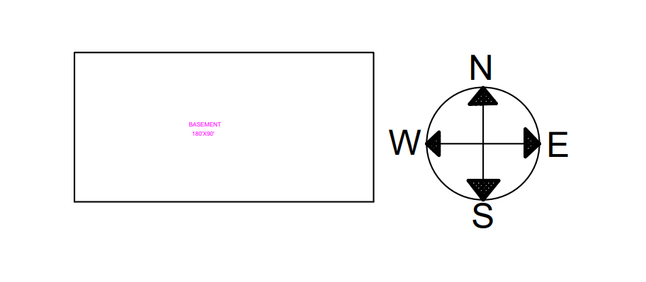**Basement(G-1)**

**(Figure-2)**

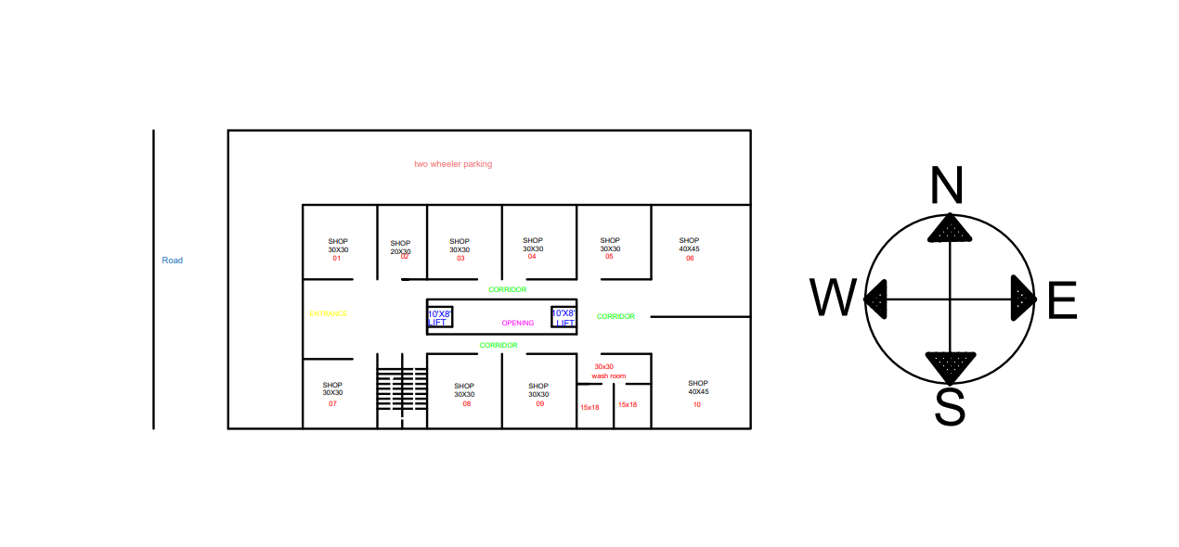**Ground floor(G)**

**(Figure-3)**

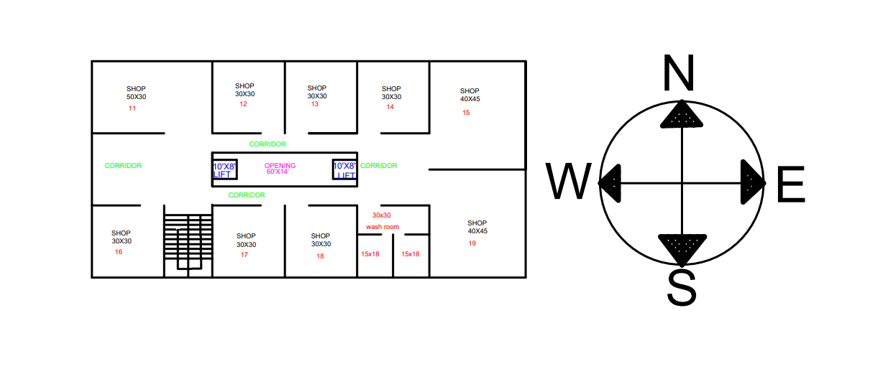

**First floor(G+1)**

**(Figure-4)**

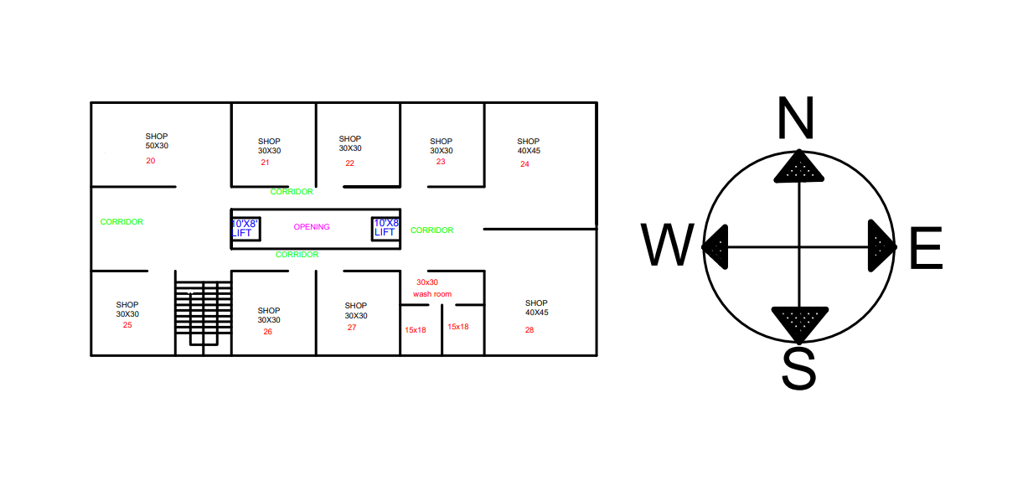

**Second floor(G+2)**

**(Figure-5)**

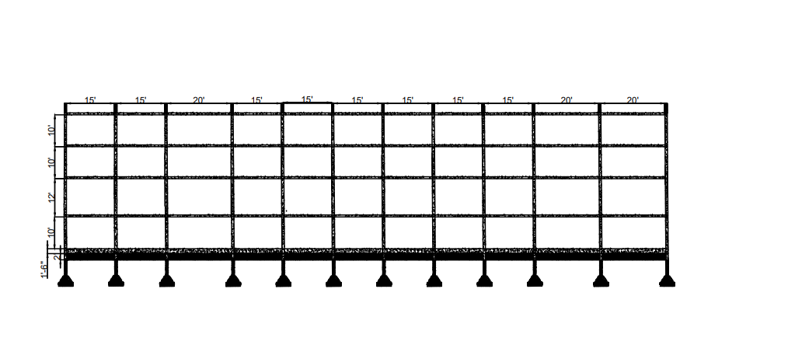

Longitudinal section B’B

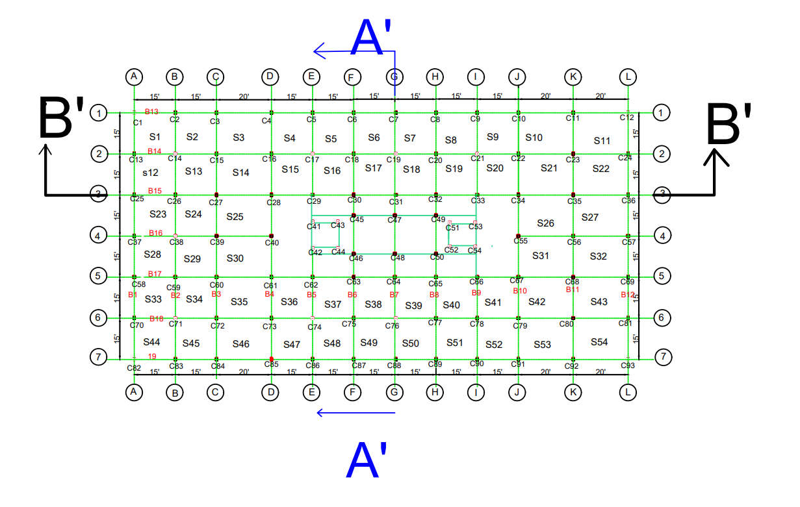

**Layout**

**(Figure-6)**

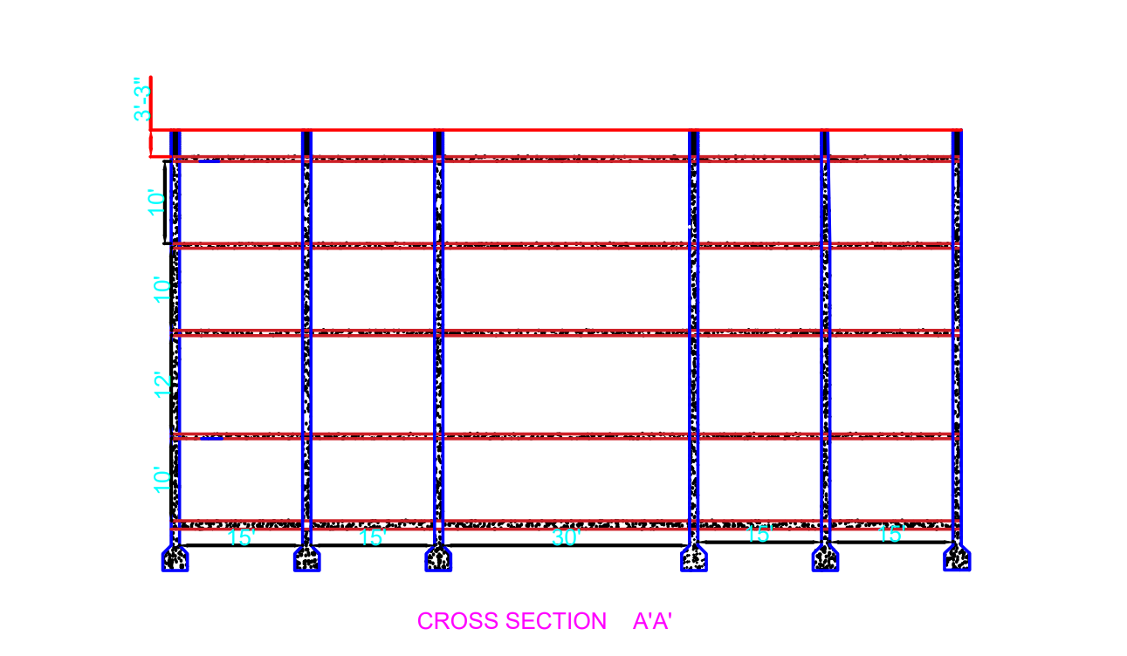



**Layout**

**(Figure-7)**

**CHAPTER-4**

**SIZE OF BEAM & COLUMN**

**4.1. BEAM:**

|  |  |  |
| --- | --- | --- |
| **S.NO.** | **BEAM** | **SIZE** |
| **1.** | **Typical beam B1, B12, B18 & B19** | **230mm*450mm** |
| **2.** | **Typical beam B2, B3, B4 & B11** | **230mm*300mm** |
| **3.** | **Typical beam B5, B6, B7, B8, B9, B13, B14, B15, B16 & B17** | **230mm*450mm** |

**4.2.COLUMN:**

|  |  |  |
| --- | --- | --- |
| **S.NO.** | **COLUMN** | **SIZE** |
| **1.** | **Column-1** | **230mm*475mm** |
| **2.** | **Column-2** | **305mm*305mm** |
| **3.** | **Column-3** | **305mm*450mm** |

**CHAPTER-5**

**ANALYSIS**

**4.1 GENERAL**

The analysis of the structure that is determination of the internal forces like bending moment, shear force, etc. in the component members, for which these members must be designed, under the action of given external loads. This process requires the knowledge of structural mechanics which includes mechanics of rigid bodies (i.e. mechanics of forces), mechanics of deformable bodies (i.e mechanics of deformations) and the theory of structures (ie. the science dealing with response of structural system to external loads). A brief review is taken of structural analysis to refresh the basic principles. The salient features of the G+2, G+1, Ground floor & G-1 floor building consist of basement floor of 3 m under the existing ground level and remaining floors with 3.60m ceiling height.

**4.2.DESIGN PHILOSOPHY**

Limit state method

**4.3 STAGES IN STRUCTURAL DESIGN**

The process of structural design involves the following stages

* Structural planning.
* Estimation of loads.
* Analysis of structure.
* Member design.
* Drawing, detailing and preparation of structures.

**4.4 MATERIAL:**

* Grade of reinforcement: Fe415
* Grade of concrete: M30
* Density of concrete: 2500Kg/m3

**LOADING**:

Dead load: Partition wall and other external walls, floor finish etc. as per the provisions of IS: 875-1987(part I)

Superimposed load: As per the provisions of IS: 875-1987(part II), uniformly distributed load of 4.0KN/m2

**PARTIAL SAFETY FACTORS:**

**Load factors:** For dead load= 1.50; for live load= 1.50;

**Material safety factor**: For reinforcement steel= 0.15; for concrete = 1.50.

**4.5 LOAD CALCULATION:**

**SLAB**

LOAD OF SLAB(G+2) :-

Size of slab = 4.432*4.432

**One OR Two way slab**

Longer span/shorter span = 4.432/4.432=1<2

Hence, two way slab

**Estimate thickness of slab**

Over all depth should be shorter span/28 to shorter span/22= 4.432/28+4.432/22

= 158mm to 201mm

Assume D = 180mm

Assume effective depth (d) = 180-20 =160mm

Assume effective cover =20mm

Dead load of slab = D*25 = 0.18*25=4.5KN/M2

Floor finish of slab = 0.075*20=1.5KN/M2

Self weight of parapet wall = (B*H) *unit weight of wall= 0.9*0.9*19=1.54KN/M2

Self weight of plaster work in parapet wall both side(12mm&15mm)

= (0.012+0.015) *0.9*20=0.486KN/M

Live load = 4KN/m2

Total load of slab (W)= Self weight + floor finish + LL

=4.5+1.5+4=10KN/m2

Factor load = 1.5*10 = 15KN/m2

**BEAM LOAD CALCULATION :-**

Total factored load of beam = 10.95KN/m2

Design of beam = 230mm*305mm

B1 & B13 are typical beam

The load of beam(B1&B13) due to slab S1=WLX/3=15*4.432/3

Factor load of beam due to slab = 22.16KN/m2

Self weight of beam(B)= b*D*25=0.23*0.305*25=1.754KN/m2

Factor weight Self of beam = 1.5*1.754=2.63KN/m2

Factored load of parapet wall = 1.5(1.54+0.486) =3.04KN/m2

Total factored load of B1= 22.16+2.63+3.04=27.83KN/m2

**ON COLUMN C1 :**

**LOAD CALCULATION OF G+2 FLOORS**

Load of column c1= ((27.83/2+27.83/2) *4.432) *3) = 123.34KN

**G+1 FLOOR:**

Load of main WALL = ((b*h*19) + (both side plaster work) *20) *2

= ((0.233*3.6576*19) + (0.012+0.015) *20)

= ((15.984+0.54) + (13.33+0.54))

=30.93KN

Load due to beam (B1 & B13) =load of beam + load of main wall

= 27.83+30.93

= 58.76KN

Load of column C1 = 123.34+(2*58.76*4.432)/2= 383.77KN

**Ground floor:**

Load due to beam (B1&B13) =58.76KN

Self weight of column = 0.230*0.305*13.72*25 = 24.06KN

Total load of column C1 = 644.2+24.06+58.76=727.02KN

**CONCLUSION**

The proposed Shopping Mall Building is planned to be constructed in Motihari (Bihar). In this building detailed plan on analysis are prepared as per standard specification. We have analyzed the loads of slabs, beams, column and footing of shopping mall according building to IS 456:2000 and we have used the limit state concept for the members. By this project the objective of entertaining the people under one roof is met with the inclusion of all the amenities and requirements. The attempt of this project made us to understand concepts analysis of slab, beam, column and footing we gained knowledge in software’s like Auto CADD and some codal provisions.

**REFERENCES**

1. National Building Code – 2005.

2. Design standards for urban infrastructure shopping centers and other public urban spaces Edition 1 Revision 0, page no: 17-4.

3. IS 456:2000 Code of Practice for Plain and Reinforced Concrete.

4. IS 875 part 2, Design loads Table 26.

5. Design of R.C.C. Structures by N. Krishna Raju.

6. SP16, Bureau of Indian standard, New Delhi, 1990.

7. Ten Principles for Rethinking the Mall, Page No: 6.

8. AUTO CADD user manual